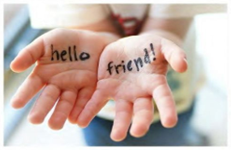
FIRST PRESBYTERIAN CHURCH
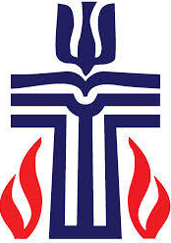

Personal Care items are available to anyone
In need, at the First Presbyterian Church
in LEAD. Call, Rev. Jil, at (605) 545-4554
to arrange a time to choose & take home. 12 Baltimore, LEAD

Personal Care Items:
Shampoo & Conditioner Paper Towel Laundry Soap/Detergent
Toothbrushes & Toothpaste Toilet Paper Dish Detergent
Fluoride Rinse Diapers Bar Soap
Dental Floss Pads & Tampons Razors
Deodorant

